Lab3 : UML diagram

By: Devin Taniguchi

Rudy Diaz

Zijun Zhao

1 use case diagram

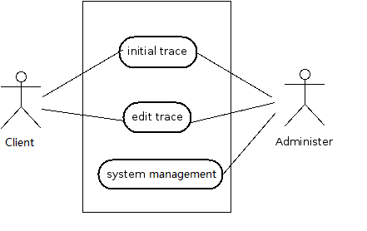

Client could initial the micromouse to trace in the maze, and also could edit the conditions such as which maze, speed of the micromouse, and etc. Administer manages the system and make sure it is work properly.

2 class diagram

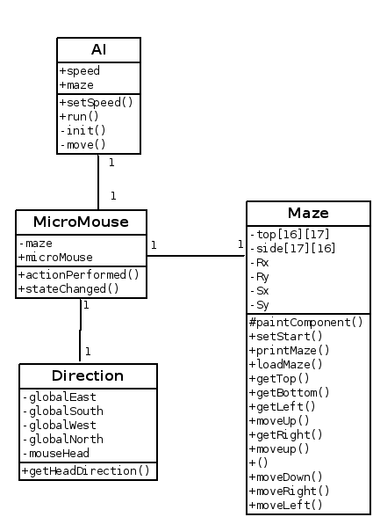

One micromouse has only one direction at each movement. At each trace micromouse is only on the certain one maze. Micromouse has only one AI system to make it smart.

3. Sequence Diagram

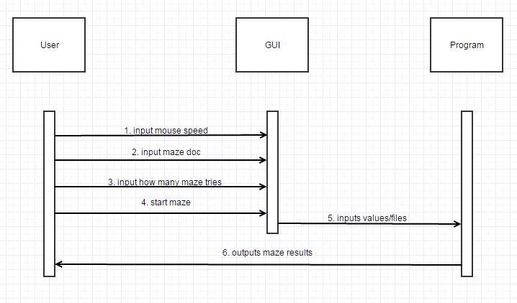

4. Component Diagram

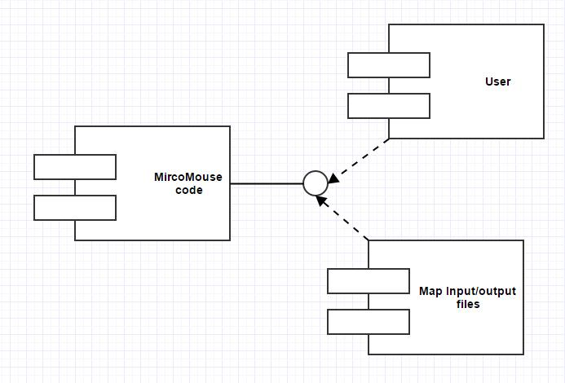

5. State Diagram

